

ITA0324-Mobile Computing

Name: A. Anusha Reg no:192472083

Slot: C Course Name: Mobile Computing

Experiment 15: Ad Hoc Wireless Network Application
Aim: To develop a wireframe for a mobile application addressing challenges related to ad hoc wireless networks using Figma.
Procedure:
- Open Figma and create a new design file.
- Select a smartphone frame for the application.
- Design a home screen showing nearby wireless devices.
- Add options for device discovery and peer-to-peer connections.
- Include a network topology view showing connected nodes.
- Add route selection, battery status, and secure data-sharing features.
- Use Prototype mode to connect the screens and test the application's navigation.

Output:
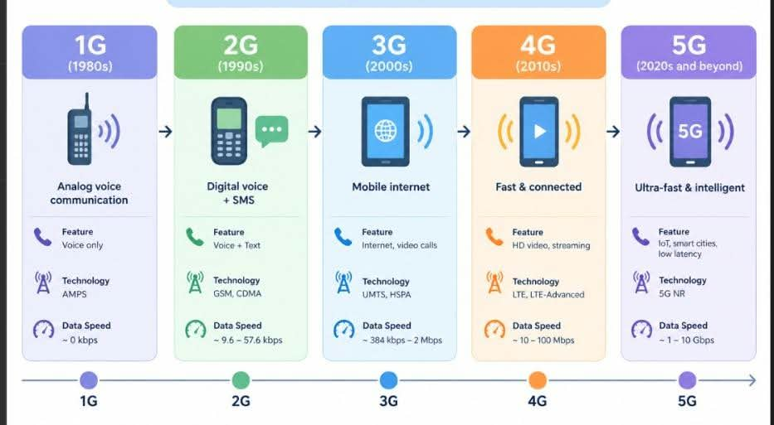
Result: Thus, a wireframe for an ad hoc wireless network management application was designed successfully using Figma.

